Name:

ID:

Submit here: <https://docs.google.com/forms/d/1kBXL-T7Smkzg-6Z2Yac40v_yC8ZDU7MTYEIieA52A34/edit>

PART 1:

1. Consider the following:

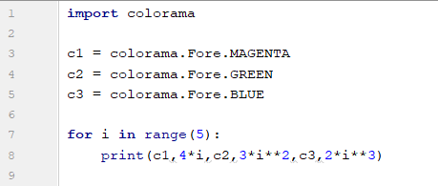

* Which color has the largest value?

1. Consider the following:

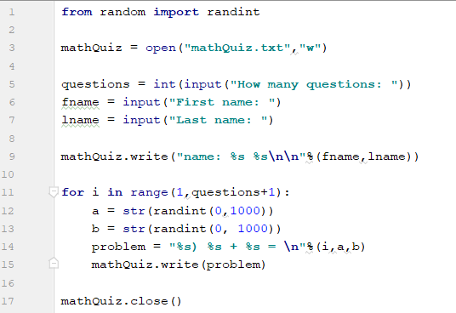

* What does this code do?
* Change the numbers in the addition problems to be less than 100 but greater than 33.
* What does **“\n”** do?
* How can you change the name of the file to **“abc.txt”**?

Part 2: [Lists: Part 2](https://runestone.academy/runestone/books/published/thinkcspy/Lists/intro-Lists.html)

1. The easiest way to clone a list involves using what operator? (10.12)
2. Evaluate the following: (10.12)

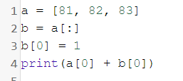

1. Evaluate the following: (10.13)

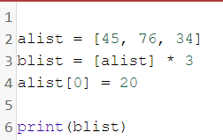

1. Evaluate the following: (10.13)

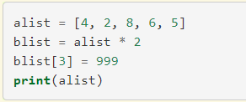

1. What are the differences between mutator, hybrid, and return results for list methods? (10.14)
2. Evaluate the following: (10.14)

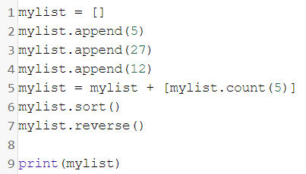

1. Evaluate the following: (10.14)

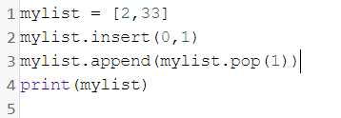

1. What position in a list is an element added if the append operation was used? (10.16)
2. What happens to the original list when append is used? What about when concatenation occurs? (10.16)
3. Consider the following: (10.17)

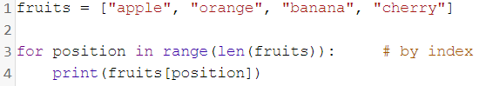

* What position is banana?
* What is fruits[3]?

PART 3:

1. Create a program that makes an *n* by *m* dimensional rectangle. Where *n* and *m* are random integers between 2 and 10.

Example:

n = 2

m = 2

**

**

n = 4

m = 3

****

****

****